1. Find the Minimum of Two Numbers Using Procedures

Ans.

**CREATE** **OR** **REPLACE** **PROCEDURE** find_min(x **IN** NUMBER, y **IN** NUMBER, min **OUT** NUMBER) **IS**

**BEGIN**

**IF** x < y **THEN**

min := x;

**ELSE**

min := y;

**END** **IF**;

**END**;

/

*-- Call the procedure*

**DECLARE**

result NUMBER;

**BEGIN**

find_min(10, 20, result);

DBMS_OUTPUT.PUT_LINE('Minimum is: ' || result);

**END**;

/

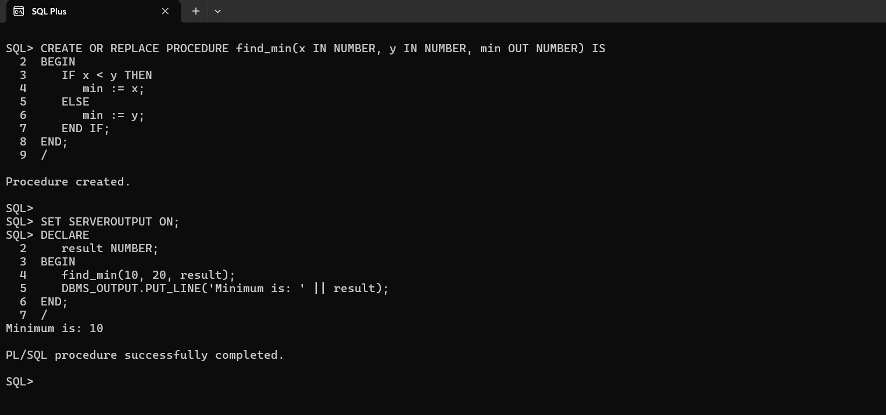

1. Insert Values into a Table Using Procedures

Ans.

**CREATE** **OR** **REPLACE** **PROCEDURE** insert_into_table(emp_id **IN** NUMBER, emp_name **IN** VARCHAR2) **IS**

**BEGIN**

**INSERT** **INTO** employees (id, **name**) **VALUES** (emp_id, emp_name);

**END**;

/

**SET** SERVEROUTPUT **ON**;

**BEGIN**

insert_into_table(**1**, 'Charan');

**END**;

/



1. Exception Handling: Zero Error

Ans.

**BEGIN**

**DECLARE**

num NUMBER := **10**;

denom NUMBER := **0**;

result NUMBER;

**BEGIN**

result := num / denom;

**EXCEPTION**

**WHEN** ZERO_DIVIDE **THEN**

DBMS_OUTPUT**.**PUT_LINE('Error: Division by zero is not allowed.');

**END**;

**END**;

/

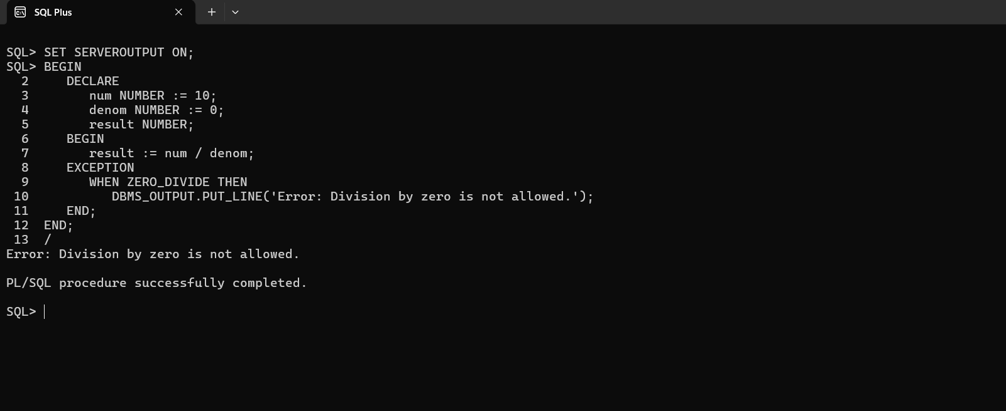

1. Find Factorial Using Functions

Ans.

**CREATE** **OR** **REPLACE** **FUNCTION** factorial(n **IN** NUMBER) **RETURN** NUMBER **IS**

fact NUMBER := **1**;

**BEGIN**

**FOR** i **IN** **1..**n **LOOP**

fact := fact * i;

**END** **LOOP**;

**RETURN** fact;

**END**;

/

-- Call the function

**BEGIN**

DBMS_OUTPUT**.**PUT_LINE('Factorial: ' || factorial(**5**));

**END**;

/

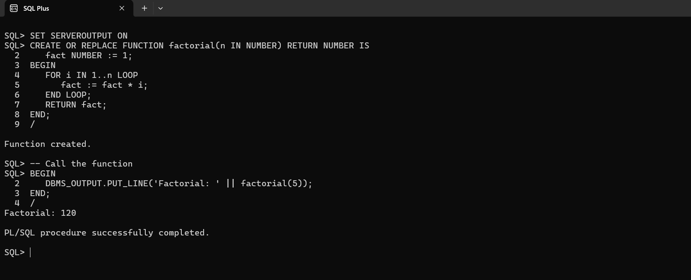

1. Exception Handling: No Rows

Ans.

**BEGIN**

**DECLARE**

v_name VARCHAR2(**50**);

**BEGIN**

**SELECT** **name** **INTO** v_name **FROM** employees **WHERE** id = **100**;

**EXCEPTION**

**WHEN** NO_DATA_FOUND **THEN**

DBMS_OUTPUT**.**PUT_LINE('Error: No rows found.');

**END**;

**END**;

/

